Performance Test Assessment

**Performance Testing Assignment:**

1. Functional Requirements

* API: <https://api.tmsandbox.co.nz/v1/Categories/6327/Details.json?catalogue=false>
* Test Data: (Category ID: 6327, 6328, 6329, 6330, 6331, 6332, 6333, 6334, 6335, 6336)
* Test Assertion:
  + Check for the Response Status
  + On a successful response, validate the response with below criteria:
    - Parameter Check: Category ID
    - Text Check: "CanRelist": true
* Print following values in a csv file: Category ID, Name, Path, Promotion ID, Price
  + Please print all Promotion IDs and respective Prices per Category ID

 2. Non-Functional Requirements

|  |  |
| --- | --- |
| **NFR #** | **Description** |
| NFR-01: | Test should support Vusers (Threads) half the count of Category IDs shared in Test Data |
| NFR-02: | The test should ramp up at one VUser (Thread) per second |
| NFR-03: | Test should achieve 10 API calls in total for the 1-minute Steady State duration |
| NFR-04: | 90 percent of the times the API is expected to perform within 500 ms |

**#################################################################################**

**Steps used in completing above assignmnent:**

* Apache JMeter was used as Performance Test Tool for this test.
* The JMeter Script [PTAssignment.jmx](https://github.com/krbhalwane/Public/blob/main/PT/PTAssignment.jmx) was created for the above mentioned API endpoint URL.
* The API call (Category_Details) was parameterized for Category IDs given above using [CategoryID.csv](https://github.com/krbhalwane/Public/blob/main/PT/CategoryID.csv) file with the help of “**CSV Data Set Config**” element in JMeter.
* Test assertions are applied by using “**Response Assertion**” element. Passing/Failing of assertion have two parts. First part instructs JMeter to check the successful response code (i.e. 200) by keeping “**Ignore Status**” field is unchecked and then in the second part, below two patterns are searched and validated to confirm if we have received correct response,
  + - Parameter Check: Category ID
    - Text Check: "CanRelist": true
* In order to capture the Category ID, Name, Path, Promotion ID, Price from the response of the API call, “**JSON Extractor**” element was used.
* The above captured values were printed in csv file by using custom code written in “**JSR223 PostProcessor**” element.
* The script was executed for 10 iterations for all Category Ids and it worked as expected.
* Then the script was updated with variables to meet the NFRs - ${VUusers}, ${Rampup}, ${SteadyState} in “**Thread Group**” element and ${TPM} in “**Constant Throughput Timer**” element, etc. Also these variables are updated as custom properties in User Defined variables so that we can pass/change them as required while running the test command in Non-GUI mode.
* The test was executed with 5 Vusers with 5 sec Rampup to achieve total 10 API calss during 1 min steady state duration. Refer below the screenshot of execution done in Non-GUI mode.

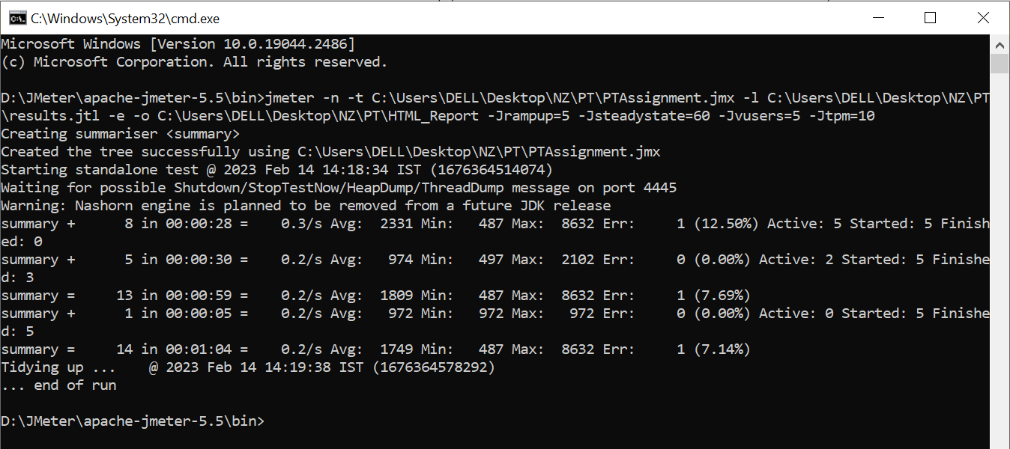

* Navigate to “<JMeter-Home>\bin” folder in command prompt and execute below command to run the test,

*jmeter -n -t C:\Users\DELL\Desktop\NZ\PT\PTAssignment.jmx -l C:\Users\DELL\Desktop\NZ\PT\results.jtl -e -o C:\Users\DELL\Desktop\NZ\PT\HTML_Report -Jrampup=5 -Jsteadystate=60 -Jvusers=5 -Jtpm=10*

Here the path after -t is .jmx file (JMeter script) path,

the path after -l is .jtl file path,

the path after -e -o is path for HTML report to be generated after the test execution.

The names with -J are the custom properties (declared as User Defined Variables in the script) to which we can pass values while running the command. If no values are passed then default values mentioned in User Defined Variables section will be passed during execution.

* After the test is complete open the “index.html” file in [HTML_Report.zip](https://github.com/krbhalwane/Public/blob/main/PT/HTML_Report.zip) folder

**Performance Test Report:**

Eclosed below the summary of test executed,

|  |  |
| --- | --- |
| Scenario | Category_Details API Performance Test |
| Time | 14-Feb-23 14:26 to 14:27 IST |
| Test Duration | 1 minute |
| TPM Simulated | 10 |
| TPM Achieved | 10 |
| Errors | 6.67% |
| Overall Status | Failed to meet the Response Time SLA |

**Observations:**

* + Total 15 requests were sent during this test out of which 5 are during ramp up & 10 are during steady state duration.
  + Only one request failed during this test due to Assertion failure for Category Id – 6331.
  + The 90th Percentile respone time is 1840 ms which does not meet the SLA as per NFR-04.
  + Around 13 requests are showing response time between 500 ms to 1500 ms. Out of them 10 requests are showing response time less than 700 ms.
  + Refer the “index.html” file in [HTML_Report.zip](https://github.com/krbhalwane/Public/blob/main/PT/HTML_Report.zip) folder for more details on performance metrics and the graphs.
  + Refer exported values for Category ID, Name, Path, Promotion ID, Price in a csv file [ExportData.csv](https://github.com/krbhalwane/Public/blob/main/PT/ExportData.csv)

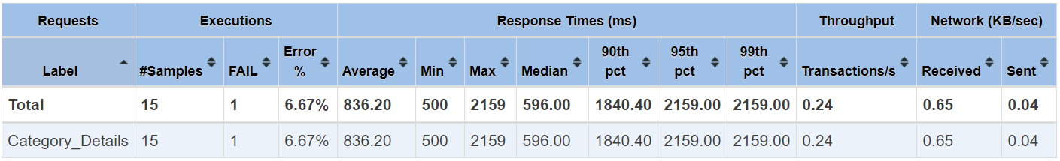

**Error Details:**



**Graphs:**

**ResponseTime Percentiles**

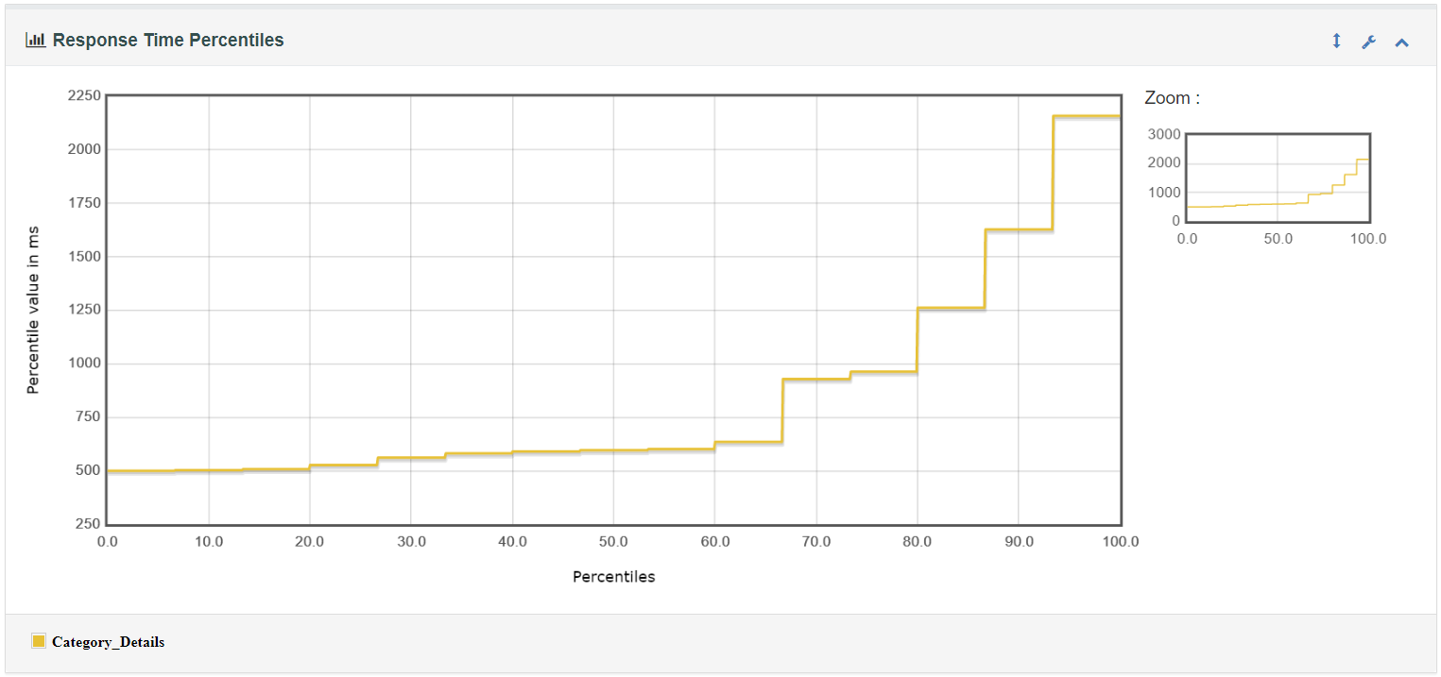

**Response Time Overview**

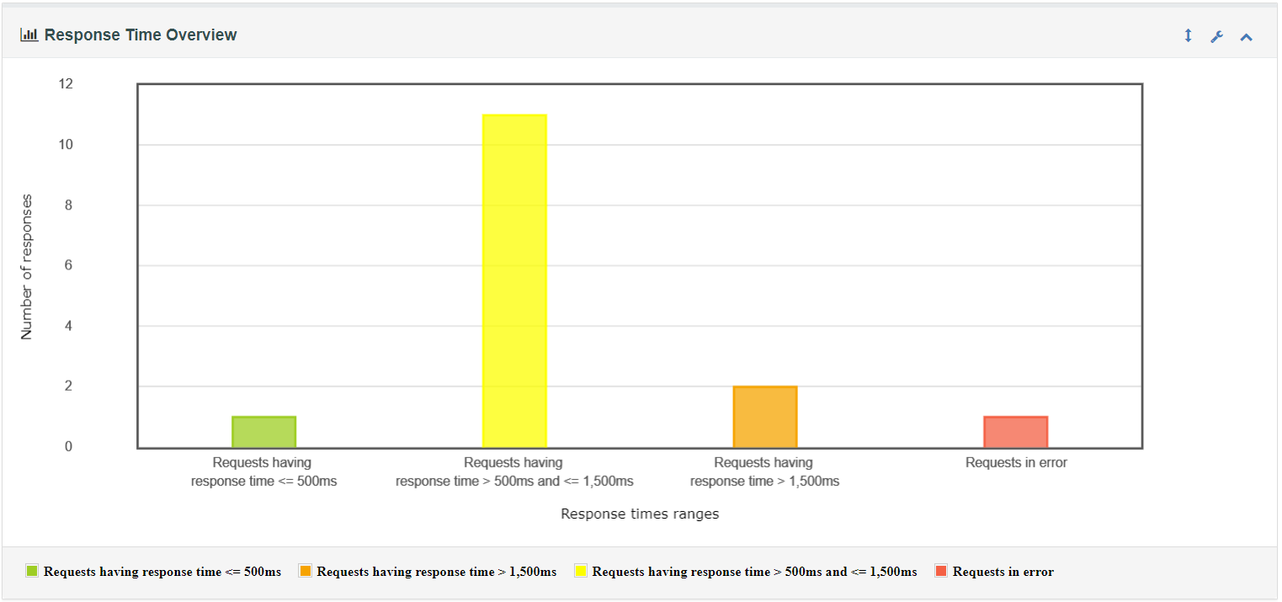

**Response Time Distribution**